|  |  |  |  |  |
| --- | --- | --- | --- | --- |
| Originating department : | **Flight Experimentation** | | | Date : |
| DCAS |  |
| Team number : | Objective : | | | Flight No: |
|  | **Acceptance flight** | | |  |
| Aircraft : | Crew : | Call sign : | Frequencies : | IFF : |
| Vulcanair P68  F-HTLI | Pilot : kg  Pilot : kg  FTE : kg | LI | LFCL TWR : 122.7  GROUND :  ATIS : 128.8 |  |
| Step : | Take Off : | Land : |  | Expected flight time : |
|  |  |  |  | 1h |

# **Purpose of the Flight**

* Flight to check the compliance with the contractor specifications.

# **Special Conditions**

**%**

* Weight :  kg (luggage :  kg) C of G : **17% Mini Maxi** **31%**
* Fuel :  L
* Weather : clear horizon for maneuvers, no turbulence, Ts, Zi & Vi constant.

# **Safety**

Minimum landing fuel : 60 **l Bingo 100l**

* 1,1Vs = 68kts at 1900kg, flaps 0°, Bank Angle 0°
* VNE = 201 kts ; VA = 137 kts
* VFET/O% = 161 kts, VFELDG = 111kt,
* Load factor: With flaps 0° **-1 < n < + 3.74 g**  / with flaps 15° or 35° **0 < n < 2 g**
* Anti-collision = look outside, clean communication with ATC and ground
* Birds collision risk
* Monitor fuel balance
* Max Bank Angle 60°
* **Risk 1: Difficult maneuvers**

⇨ Recover before maximum attitude: -10°<<+20°, -20°<< +20°

⇨ Avoid VNE or reduce power and slowly pitch up

**High risk**

⇨ **Recover** / **STOP TEST** **at stall warning**

* **Risk 2: Collision with bird or aircraft**

**Low risk**

⇨ Maneuvers performed under CER (Centre essais receptions)

Stall Speeds:

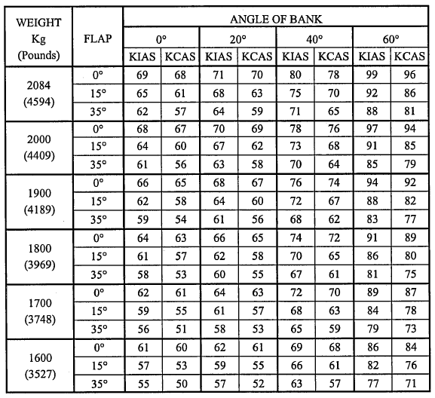

**Limitation of the aircraft**

We will proceed the flight test in the normal category. Those limitations are not relevant for the utility category.

1. Maximum take-off weight: **2084 kg**

2. Maximum landing weight: **1980 kg**

3 Maximum Zero fuel weight: **1890 Kg**

4. Maximum luggage weight: **180 kg**

5**.** Autopilot:

* + Prohibited with more than 15° flaps
  + Minimum Altitude: **200ft AGL** during approach

**1000ft AGL** during Cruise

* Max A/P operating Speed: **170 KIAS**

**Limitation of the engine**

1. Max cylinder head temperature: **475°F**
2. Max Oil Pressure: **90 PSI**
3. Min Fuel Pressure: **14 PSI**
4. Max Fuel Pressure: **36 PSI**
5. Max EGT: **1380°F**
6. Continuous maximum engine speed: **2700 RPM**

# **Flight Profile**

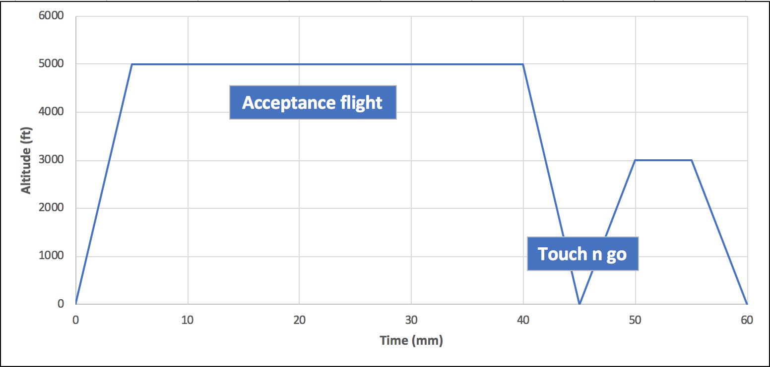

# **Flight Sequence**

1. Engine start up : Std procedures /F/CTL check
2. Taxi: Std procedure
3. Take Off: Std procedure
4. Normal Climb to 5000ft/Vi 92kt

* Check Ts on FTI at each 500 ft (atmosphere survey) (**FTE)**

1. Pre-flight inspection check-list (**Check-list inside P68**)
2. Start Test description

|  |  |  |  |  |  |
| --- | --- | --- | --- | --- | --- |
| **ITEM** | **TEST DESCRIPTION** | | | | **LIMITS** |
| **1** | **ENGINE START**  (USUALLY LEFT ENGINE FIRST) | | | |  |
| BATTERY | **ON** | | | 24V+/-1 |
| MAGNETO SWITCH | **ON** | | |  |
| THROTTLE | **2cm FWD** | | |  |
| AUXILIARY FUEL PUMP | **ON** | | |  |
| MIXTURE CONTROL | **RICH** | | | Wait for 3-5 USG FF |
| MIXTURE CONTROL | **CUT OFF** | | |  |
| AUXILIARY FUEL PUMP | **OFF** | | |  |
| STARTER | **ENGAGE** | | |  |
| STARTER LIGHT | **CHECK ON** | | |  |
| MIXTURE CONTROL | **ADVANCE** | | | Engine should not crank more than 10 seconds |
| STARTER LIGHT | **CHECK OFF** | | |  |
| OIL PRESSURE | **CHECK RISING** | | |  |
| LH GEN | **ON** | | |  |
| LH ALT OUT LIGHT | **OFF** | | |  |
| THROTTLE | **1200 RPM** | | |  |
|  | **RIGHT ENGINE**  REPEAT PROCEDURE | | | |  |
| VHF COM | **ON AND SET** | | |  |
| CLOCK | **CHECK** | | |  |
| **2** | **MAGNETO CHECKS** | | | |  |
| LH – RH THROTTLE | **<1000 RPM** | | |  |
| **LH ENGINE** | | | |  |
| BOTH MAGNETO: **OFF** |  | | |  |
| LH ENGINE TENDENCY TO SHUT DOWN | | | |  |
| BOTH MAGNETO: **ON** |  | | |  |
| **RH ENGINE** | | | |  |
| BOTH MAGNETO: **OFF** |  | | |  |
| RH ENGINE TENDENCY TO SHUT DOWN | | | |  |
| BOTH MAGNETO: **ON** |  | | |  |
| **3** | **ALTERNATORS CHECK** | | | |  |
| LH – RH THROTTLE | **1500 RPM** | | |  |
| **ELECTRICAL EQUIPMENTS ON TO OBTAIN 50A** | | | |  |
| LOADS: | **LH: ________ A** | | | LH+RH<20A |
| **RH: ________ A** | | |
| LH FIELD **OFF** | **LH LOAD ________ A** | | | -1 +1 |
| **RH LOAD ________ A** | | | RH+LH LOAD |
| LH ALT OUT **LIGHT ON** | **_______ A** | | | ON |
| LH FIELD  **ON** | **_______ A** | | | LH LIGHT ALT OFF |
| VERIFY CORRECT LOAD DISTRIB. | **_______** | | | OK OR NOT OK |
| RH FIELD  **OFF** | **RH LOAD _______ A** | | | -1 +1 |
| **LH LOAD _______ A** | | | RH+LH LOAD |
| RH ALT OUT **LIGHT ON** |  | | | ON |
| RH FIELD **ON** |  | | | RH LIGHT ALT OFF |
| VERIFY CORRECT LOAD DISTRIB. |  | | | OK OR NOT OK |
| **4** | **ALTERNATE AIR CHECK** | | | |  |
| LH – RH THROTTLE | **1500 RPM** | | |  |
| **LH ALTERNATE AIR** | | | |  |
| **PUSH** | **PULL** | | | DROP (PULL) |
| **_______RPM** | **_______RPM** | | | 50 – 100 RPM |
|  |  | | |  |
| **RH ALTERNATE AIR** | | | |  |
| **PUSH** | **PULL** | | | DROP (PULL) |
| **_______RPM** | **_______RPM** | | | 50 – 100 RPM |
| **5** | **PROPELLER CHECK FEATHER PROPELLER TWO BLADES** | | | |  |
| LH – RH THROTTLE | **1500 RPM** | | |  |
| **LH PROPELLER LEVER** | | | |  |
| LOW PITCH RPM | | | **_______** |  |
| HIGH PITCH RPM | | | **_______** |  |
| FEATHER CHECK (MINIMUM 1000RPM) | | | **_______** | MINIMUM 1000RPM |
| CHECK OIL PRESSURE | | |  |  |
| **RH PROPELLER LEVER** | | | |  |
| LOW PITCH RPM | | | **_______** |  |
| HIGH PITCH RPM | | | **_______** | MINIMUM 1000RPM |
| FEATHER CHECK (MINIMUM 1000RPM) | | | **_______** |  |
| CHECK OIL PRESSURE | | |  |  |
| **6** | **MIXTURE CHECK** | | | |  |
| LH – RH THROTTLE | **1500 RPM** | | |  |
| MIXTURE FULL RICH FF | **_______** USG | | |  |
| REDUCE LH MIXTURE  Search max RPM | **_______** RPM | | |  |
| CHECK EGT’s LH ENGINE INCREASE | YES/NO | | |  |
| CHECK FF LH ENGINE DECREASE | YES/NO | | |  |
| CHECK RPM LH ENGINE INCREASE | YES/NO | | |  |
| ADVANCE LH MIXTURE  FULL Forward |  | | |  |
| MIXTURE FULL RICH FF | **_______** USG | | |  |
| REDUCE RH MIXTURE  FULL Search max RPM | **_______** RPM | | |  |
| CHECK EGT’s RH ENGINE INCREASE | YES/NO | | |  |
| CHECK FF RH ENGINE DECREASE | YES/NO | | |  |
| CHECK RPM RH ENGINE INCREASE | YES/NO | | |  |
| ADVANCE RH MIXTURE  FULL FORWARD |  | | |  |
| **7** | **CROSSFEED CHECK** | | | |  |
| TENDENCY TO SHUT DOWN | | YES/NO | | Wait 20 sec |
|  |  | | | |  |
|  |  | | |
| **8** | **ENVIRONMENTAL CONTROL SYSTEM** | | | |  |
| LH – RH THROTTLE | **1500 RPM** | | |  |
| SWITCH: WIND DEFR. ON / OFF |  | | |  |
| SWITCH: FAN / ON |  | | |  |
| SWITCH: LOW / HIGH | **LOW** | | |  |
| VERIFY CORRECT FUNCTION | | | |  |
| YES | NO | | | YES |
| **ENVIRONMENTAL CONTROL SYSTEM CUT OFF CHECK** | | | |  |
| **LH GEN** | **OFF** | | |  |
| VERIFY FAN OFF | YES/NO | | | OFF  LH LIGHT ALT ON |
| LH GEN | **ON** | | |  |
| VERIFY FAN ON |  | | | ON  RH LIGHT ALT OFF |
| **RH GEN** | **OFF** | | |  |
| VERIFY FAN OFF | YES/NO | | | OFF  RH LIGHT ALT ON |
| RH GEN | **ON** | | |  |
| VERIFY FAN ON |  | | | ON  RH LIGHT ALT OFF |
| **9** | **MAGNETOS DROP CHECK** | | | |  |
| **LH ENGINE** | | | |  |
| LH – RH THROTTLE | **2100 RPM** | | |  |
| LH MAGNETO: **OFF** | **______ RPM** | | | MAX DROP 175 RPM |
| LH MAGNETO: **ON** | **______ RPM** | | | 2100 RPM |
| RH MAGNETO: **OFF** | **______ RPM** | | | MAX DROP 175 RPM |
| RH MAGNETO: **ON** | **______ RPM** | | | 2100 RPM |
| DELTA LH - RH | **______ RPM** | | | MAX DELTA 50RPM |
| **RH ENGINE** | | | |  |
| LH MAGNETO: **OFF** | **______ RPM** | | | MAX DROP 175 RPM |
| LH MAGNETO: **ON** | **______ RPM** | | | 2100 RPM |
| RH MAGNETO: **OFF** | **______ RPM** | | | MAX DROP 175 RPM |
| RH MAGNETO: **ON** | **______ RPM** | | | 2100 RPM |
| DELTA LH - RH | **______ RPM** | | | MAX DELTA 50RPM |
| **10** | **FLIGHT CONTROLS** | | | |  |
| **CHECK FREE AND FULL TRAVEL** | | | |  |
| ELEVATOR UP/DWN | **______** | | |  |
| AILERON LH/RH | **______** | | |  |
| RUDDER LH/RH | **______** | | |  |
| NOSE-WHEEL STEERING | **______** | | |  |
| ELEVATOR TRIM  FULL UP / FULL DWN / T.O |  | | | FULL RANGE |
| RUDDER TRIM  FULL LEFT / FULL RIGHT / CENTRE |  | | | FULL RANGE |
| FLAPS  CYCLE DOWN / UP / TAKE-OFF |  | | | FULL RANGE |
| **11** | **BEFORE TAXI** | | | |  |
| BATTERY & ALTERNATOR SWITCHES | **ON** | | |  |
| NAVIGATION LIGHTS | **AS REQUIRED** | | |  |
| TAXI/LANDING LIGHTS | **AS REQUIRED** | | |  |
| INTERCOM | **CHECK** | | |  |
| GYRO INSTRUMENTS | **SET** | | |  |
| ALTIMETER SET | **QNH ______** | | |  |
| RADIOS | **ON, SET, CHECK** | | |  |
| PARKING BRAKE | | **CHECK** | | SET |
| **12** | **TAXI** | | | |  |
| BRAKE | | **CHECK** | |  |
| DIRIGEABILITY LEFT/RIGHT FULL TRAVEL | | **CHECK** | |  |
| TAXIWAY HDG / HSI HDG Compare | | **CHECK** | |  |
| **13** | **BEFORE TAKE-OFF** | | | | SET |
| **FUEL SELECTORS** | **RH ENG**  **=> RH TANK** | | |  |
|  | **LH ENG**  **=> LH TANK** | | |  |
| AUXILIARY FUEL PUMPS | **ON** | | |  |
| FLIGHT INSTRUMENTS | **SET and CHECK** | | |  |
| ENGINE INSTRUMENTS | **CHECK** | | | GREEN ARC |
| RADIO | **CHECK** | | |  |
| ALTERNATE AIR | **OFF** | | |  |
| ANNUNCIATOR | **CLEAR** | | |  |
| RUDDER TRIM | **SET** | | |  |
| LONGITUDINAL TRIM | **SET FOR T/O** | | | WHITE ARC |
| FLAPS | **15°** | | |  |
| TIME | **___________** | | |  |
| **14** | **TAKE-OFF** | | | |  |
| **STANDARD PROCEDURE**  **FLAPS 15°** | | | |  |
| RPM | |  |  | | --- | --- | | **LH** | **RH** | | **____** | **____** | | | | 2600-2675 RPM |
| MANIFOLD PRESSURE | |  |  | | --- | --- | | **LH** | **RH** | | **____** | **____** | | | | 28 – 30 In. Hg. |
| CYL HEAD TEMP | |  |  | | --- | --- | | **LH** | **RH** | | **____** | **____** | | | | MAX 475°F |
| OIL TEMPERATURE | |  |  | | --- | --- | | **LH** | **RH** | | **____** | **____** | | | | MAX 245°F |
| OIL PRESSURE | |  |  | | --- | --- | | **LH** | **RH** | | **____** | **____** | | | | MAX 86 PSI |
| FUEL FLOW | |  |  | | --- | --- | | **LH** | **RH** | | **____** | **____** | | | | 17.5 – 19.5 GPH |
| EGT | |  |  | | --- | --- | | **LH** | **RH** | | **____** | **____** | | | | 1180°F – 1380°F |
| |  |  |  | | --- | --- | --- | | **WEIGHT** | **TAKE-OFF SPEED** | | | **VLOF** | **VSCREEN** | | **2084** | **71** | **79** | | **1900** | **68** | **76** | | **1800** | **65** | **73** | | | | |  |
| **15** | **GET TO TEST AREA** | | | |  |
| AUXILIARY FUEL PUMPS | **OFF** | | |  |
| **16** | **INSTRUMENTS & AVIONICS** | | | |  |
| ALT: 5000 FT |  | | |  |
| SPEED: AS REQUIRED |  | | |  |
| **Emergency static source (vents on)**    Δ KIAS = kt ΔFT = ft  **CHECK FOR CORRECT OPERATION** | | | |  |
| COM 1 | **CHECK** | | |  |
| COM 2 | **CHECK** | | |  |
| NAV 1 | **CHECK** | | |  |
| NAV 2 | **CHECK** | | |  |
| AUDIO PANEL | **CHECK** | | |  |
| TRANSPONDER | **CHECK** | | |  |
| ADF | **CHECK** | | |  |
| RMI | **CHECK** | | |  |
| DME | **CHECK** | | |  |
| MAGNETIC COMPASS | **CHECK** | | |  |
| ATTITUDE INDICATOR | **CHECK** | | |  |
| ALTIMETER STBY | **CHECK** | | |  |
| AIRSPEED INDICATOR STBY | **CHECK** | | |  |
| **WIND INFORMATION** | **CHECK** | | |  |
| **TAS600** | **CHECK** | | |  |
| **STORMSCOPE** | **CHECK** | | |  |
| **17** | **STALLS**  FLAPS 0° : SW at …..….. Kt Stall at ………….Kt  FLAPS 15° : SW at …..…. .Kt Stall at ………….Kt  FLAPS 35° : SW at …..… ..Kt Stall at ………….Kt | | | |  |
| **18** | **SPEED STABILISATIONS**  Time : HDG : Zp :  Stabilize 80, 150, (check manoeuvrability)  Stabilize180 KIAS | | | |  |
| **19** | **CHECK FOR CORRECT OPERATION AUTOPILOT** | | | |  |
| ALT: AS REQD |  | | |  |
| SPEED: UP TO MAX SPEED 180KIAS |  | | |  |
| **AUTOPILOT** | **CHECK** | | |  |
| ALT HOLD MODE | **CHECK** | | | 1,3 Vs<speed<max cruise |
| VERTICAL SPEED MODE | **CHECK** | | |  |
| HEADING MODE | **CHECK** | | |  |
| FLAPS 15° speed 100 KIAS | **CHECK** | | |  |
| CWS MODE | **CHECK** | | |  |
| NAVIGATION MODE | **CHECK** | | |  |
| APPROACH VOR/ILS | **CHECK** | | |  |
| ALTITUDE | **CHECK** | | |  |
| SELECTOR/ALERTER | **CHECK** | | |  |
| GPWS | **CHECK** | | |  |
| REMARKS: AIRCRAFT OSCILLATIONS DURING ENGAGEMENT/DISENGAGEMENT | | | |  |

|  |  |  |  |
| --- | --- | --- | --- |
| **20** | **TURNS**  Time : HDG (initial): Zp :  Stabilize 20, 30 45, 60° bank angle Left & Right | |  |
| **21** | **DETRIM TEST**  Speed : 120 KIAS power for level flight  Change elevator trim setting (Up & Down) and maintain Zp  Change Rudder trim setting (Left & Right) and maintain lateral symetry | |  |
| **22** | **VMC**  Speed : 110 KIAS   * Steady heading sideslip   Speed : 80 KIAS   * LH engine idle / RH max power * Apply full rudder smoothly and maintain heading | |  |
| **23** | **GS/ILS APPROACH** | |  |
| **STANDARD PROCEDURE AUTOPILOT ON** | |  |
| VERIFY MARKER: | OUTER: **______** |  |
|  | MIDDLE: **______** |  |
|  | INNER: **______** |
|  | |
| **STANDARD PROCEDURE AUTOPILOT OFF** | |
| VERIFY MARKER: | OUTER: **______** |
|  | MIDDLE: **______** |  |
|  | INNER: **______** |  |
| **24** | **APPROACH & LANDING (normal procedure)** | |  |
| VERIFY approach speed: | **__________** |  |
|  | |  |
| VERIFY MAX BRAKE ON GROUND | **_________** |  |
| **25** | **SHUT DOWN AND PARKING** | |  |
| AUXILIARY FUEL PUMP | OFF |  |
| FLAPS | UP |  |
| PARKING BRAKE | SET |  |
| NAVIGATION LIGHTS | OFF |  |
| TAXI/LANDING LIGHT | OFF |  |
| RADIOS | OFF |  |
| ALL SWITCHES EXCEPT BAT. | OFF |  |
| ALTERNATORS AND MAGNETO SWITCHES |  |  |
| THROTTLES | IDDLE |  |
| PROPELLER | FORWARD |  |
| MIXTURES | IDLE CUT-OFF |  |
| MAGNETO SWITCHES | OFF |  |
| BATTERY AND ALTERNATORS | OFF |  |
| SWITCHES |  |  |
| FUEL SELECTORS | OFF |  |
| CONTROL LOCKS | AS REQUIRED |  |
| TIME | **_________** |  |
|  |  |  |
|  |  |  |
|  |  |  |
|  |  |  |
|  |  |  |
|  | **NOTES:** | |  |

**Acceptance task Sharing:**

**Pilot :**

* **Check procedure**

**FTE :**  enumerate procedure

* **Note**

**FTI 1 Right:**

* **Note**

**FTI 2 Left:**

* **Note**

1. Return to base, descent & landing (STD procedure)
2. When ATC call, set QNH Lasbordes
3. Engine Off
4. Briefing with crew